**Bank of American Stock Price Research**

**Abstract:**

From 2007 to 2014, the price of stock of Bank of American is relatively stable by checking the RRV (relative realized volatility). Only one day has relatively high RRVs during 2007 to 2014. I also did count on times of no arrival trade by different seconds. Then calculate the probability of no arrival trade with Poisson model. The result is that we can use Poisson model to predict probability of no arrival trade when seconds gap is relatively small. In addition, when I plot the daily 100 seconds accumulated RV(realized volatility) and daily average RV, I found strong linear relationship between these two variables. In the end, Using the Heston model to verify if there exist linear relationship between daily average and mean reversion rate. When I use 5 days as a period to calculate the daily average RV and mean reversion rate. The significance of linear relationship is stronger.

**Introduction:**

First of all, based on the definition of RV(realized volatility), after we calculate all the 100 seconds RVs, we find all the RVs are scatter in a wide range. In order to normalize RVs and better analyze the jump effect in RV100s, we decide to use RRVs which is divide RVs by median RV. After calculating the RRVs, we divide it into different intervals. For example, in interval RRV greater than 1000, there may be one day. In interval RRV between 500 and 1000, there may be 50 days. Then we check how many days in each interval and check if the days are consecutive. The goal is to analyze the stability of stock price of Bank of American.

Secondly, since the original data have gaps between each trade, I try to use different seconds to calculate the number of gaps daily and sum them up to the whole year. Trying to predict the relationship between seconds unit and gaps, I choose Poisson distribution to calculate the number of gaps.

Thirdly, the daily average RV and daily accumulated RV is another direction to research the stability of stock price. We can check if there are outliers when we plot daily average RV and daily accumulated RV since they have strong correlation.

In the end, building Heston model can help us to discover more about daily average realized volatility. From the formula of Heston Model. I calculate the daily average RV for each day and also 5 days average RV. Preferring 5 days average RV is because 5 day have larger sample size therefore the variance may be smaller.

**Body of the paper:**

For the first question, we get the there only 1 day that has RRV greater than 1000. The day is May 6th, 2010. From the output we can see that the interval 0 to 2.5 has 95.1% days and it means that most of days do not have large realized volatility. The interval 0 to 2.5 and 2.5 to 5 contains more than 99% of days. It indicates the stock prices of Bank of American are relatively stable and will not change too much in a day.

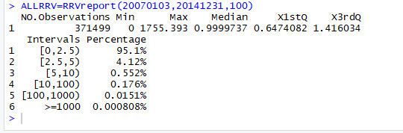

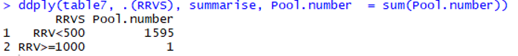

Secondly, the number of gaps is approximately fit Poisson distribution. The outputs from 2007 to 2014 indicates that if we choose small seconds to count gaps, the result will be much closer to the Poisson distribution probability. However, when we choose larger seconds to count gaps, the difference between empirical probability and Poisson model probability will be relatively large. This trend can be clearly seen in every year.

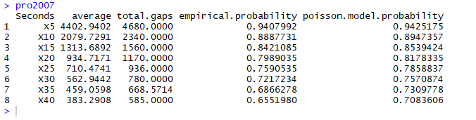

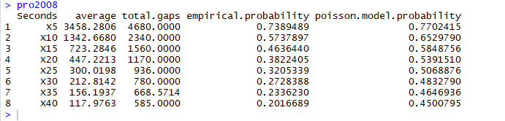

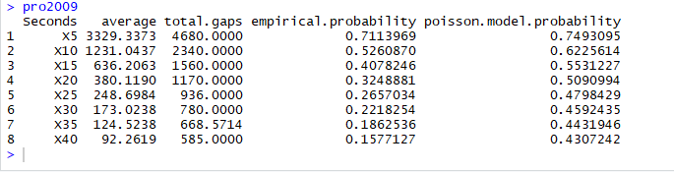

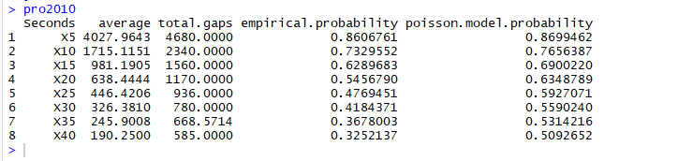

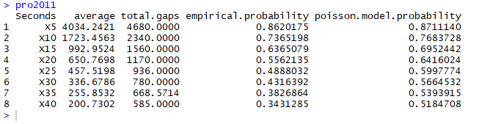

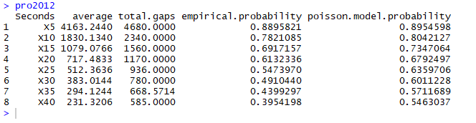

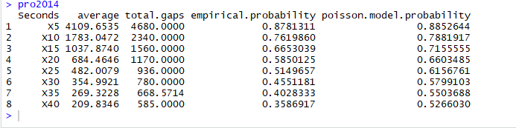

Thirdly, the daily accumulated RV and daily average RV are really close to each other and they have approximately linear relationship. Except just a few outliers, many points are approximately in linear relationship. The followings are the graphs for each year.

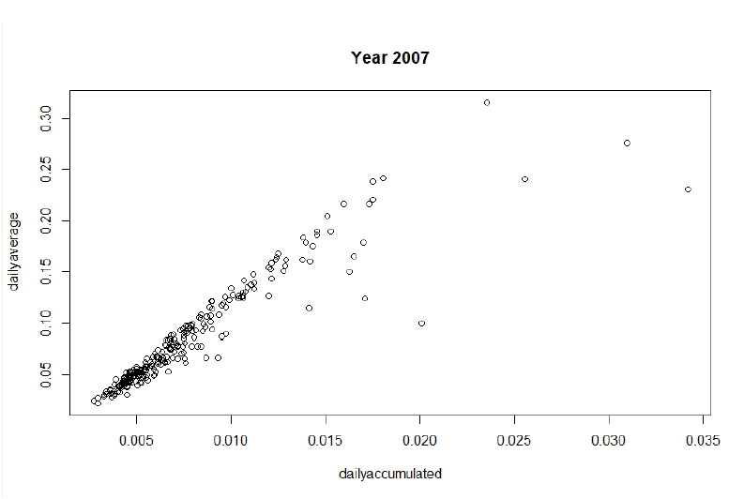

The plot of 2007 is closed to linear relationship, but it does have several obvious outliers. Those outliers are on 20070227,20070228, 20070301 and 20070816. Overall the shape is approximately linear.

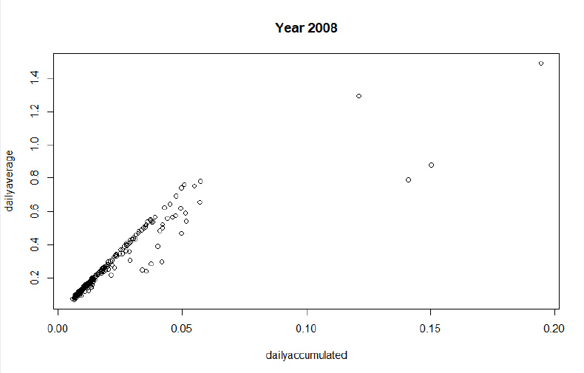

The plot of 2008 looks like that it has two separate parts. The first part which looks closed to linear and the second part is 4 distinct outlier points. These outlier points are 20081010, 20081016, 20080919 and 20080122.

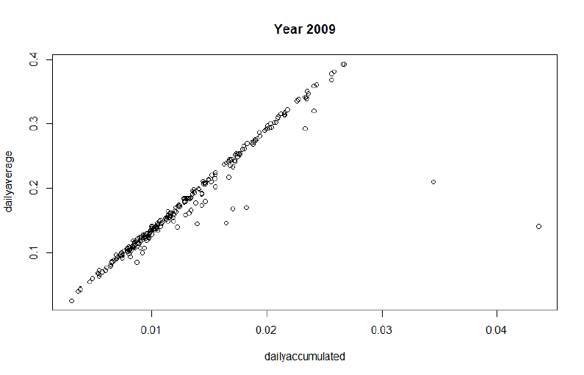

The plot of 2009 has major points remaining on linear relationship and two outlier points on the right side. These outlier points’ dates are 20091207 and 20090916.

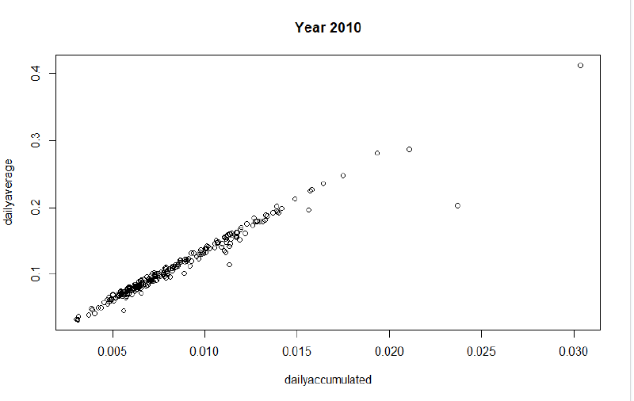

The plot of 2010 does not have obvious outlier point and is closed to linear relationship.

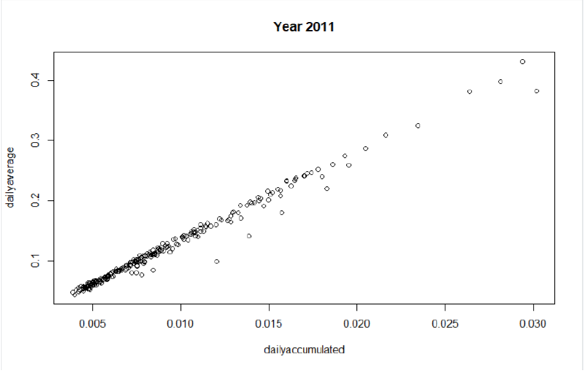

The plot of year 2011 is interesting since it is closed to linear relationship and it does not have obvious outliers.

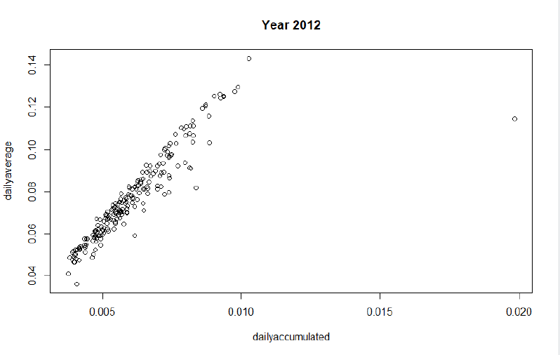

There is one obvious outlier point which is on the date 20120724

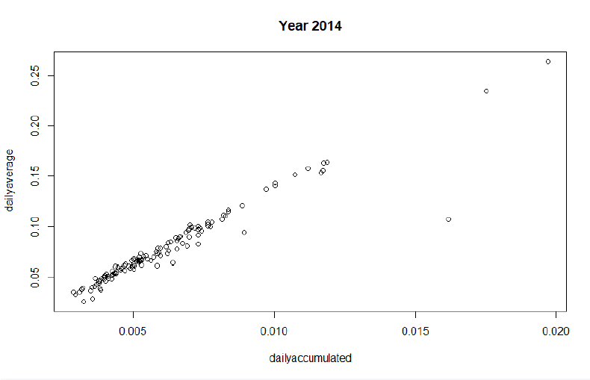

The plot of 2014 is almost on the one line except for one point on the data 20141027

In the end, after we built the Heston model and calculate the one day period and five day period for daily average and mean reversion rate. We find that since we use different number of days as period, the 5 day period obviously have smaller variance. The most obvious is the outlier point date 20100506. In one day period, the alpha of that day is more than 4 but in five day period, the alpha is less than 4.

The following is one day period alpha and beta plots.

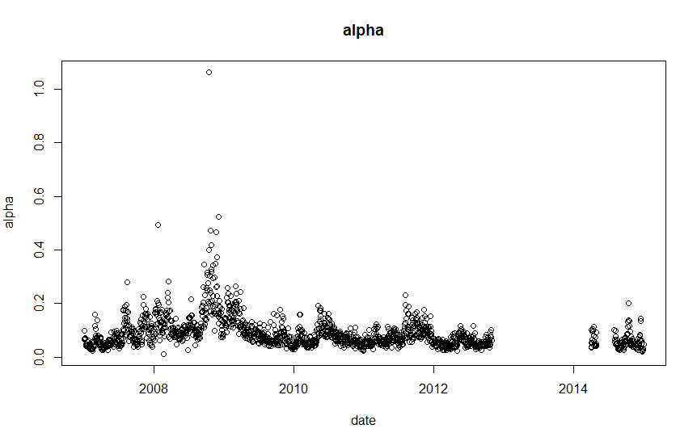

(alpha without outlier 20100506)

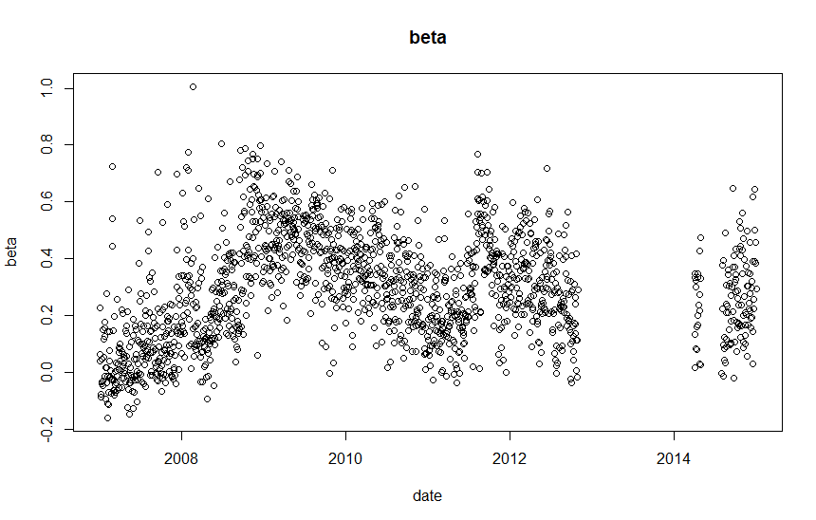

The beta plot does not have obvious or significant outliers. The highest beta is a little bit larger than 1.

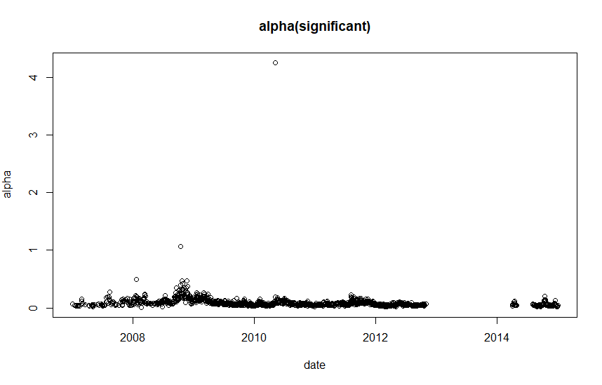

（The plot with outlier 20100506）

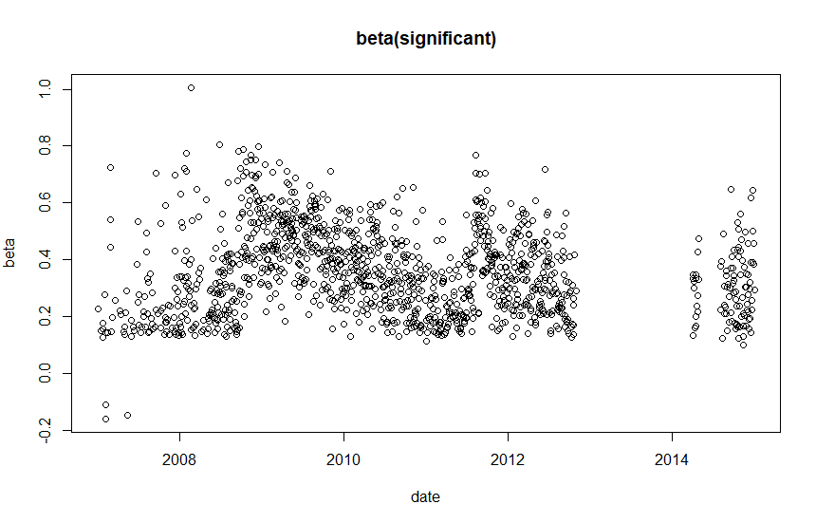

Beta graph with only significant days does not have significant or obvious outlier.

The following is 5 day period:

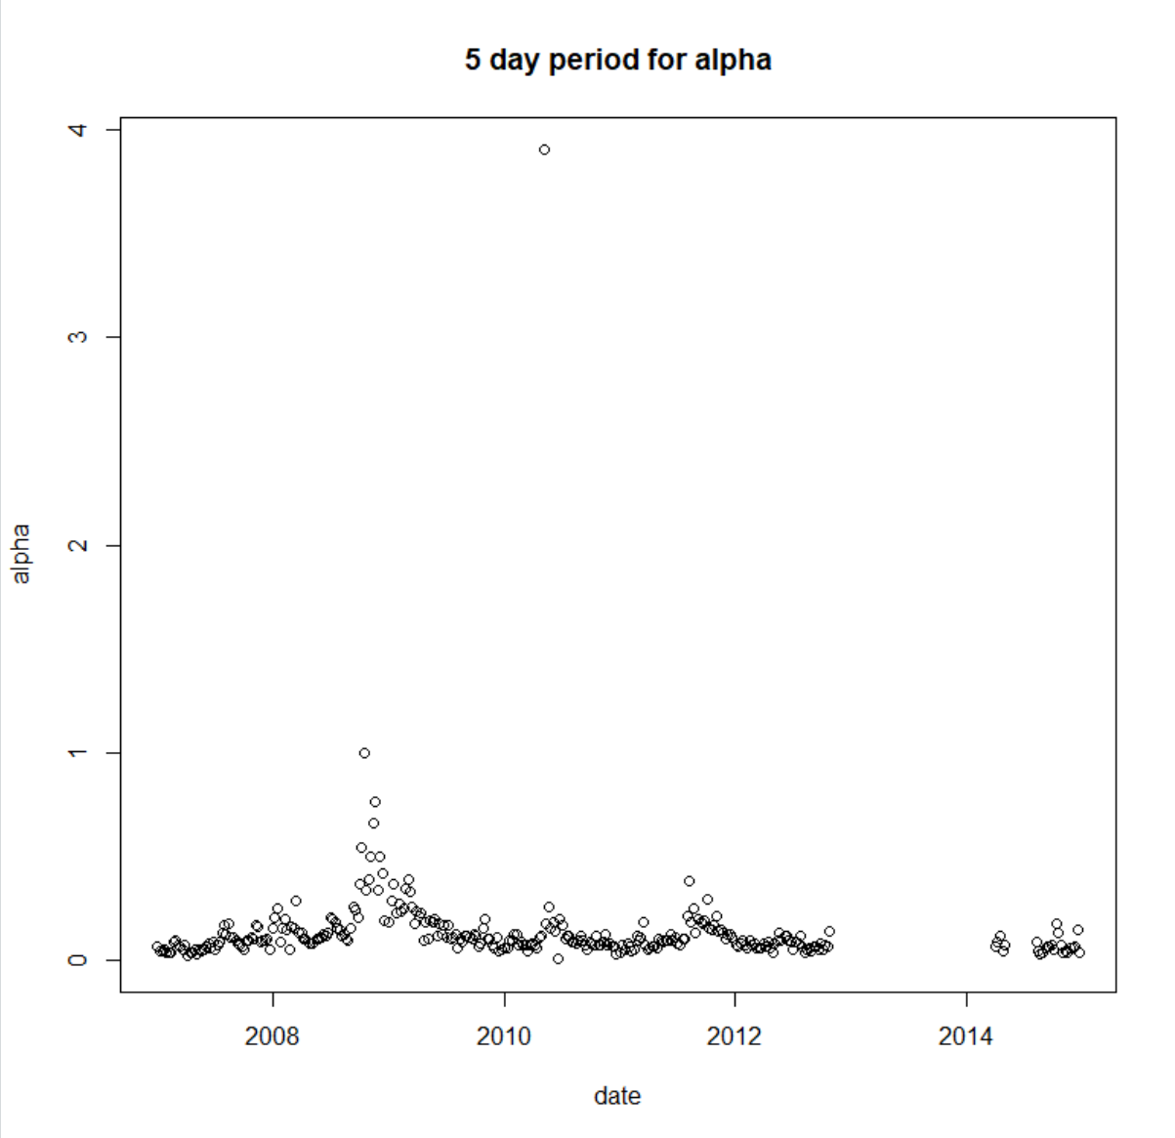

Here we use five day as a period, then it is clearly that the variance of the alpha becomes smaller. Previously in one day period, the outlier 20100506 is slightly greater than 4 but in five day period, it is below 4 now.

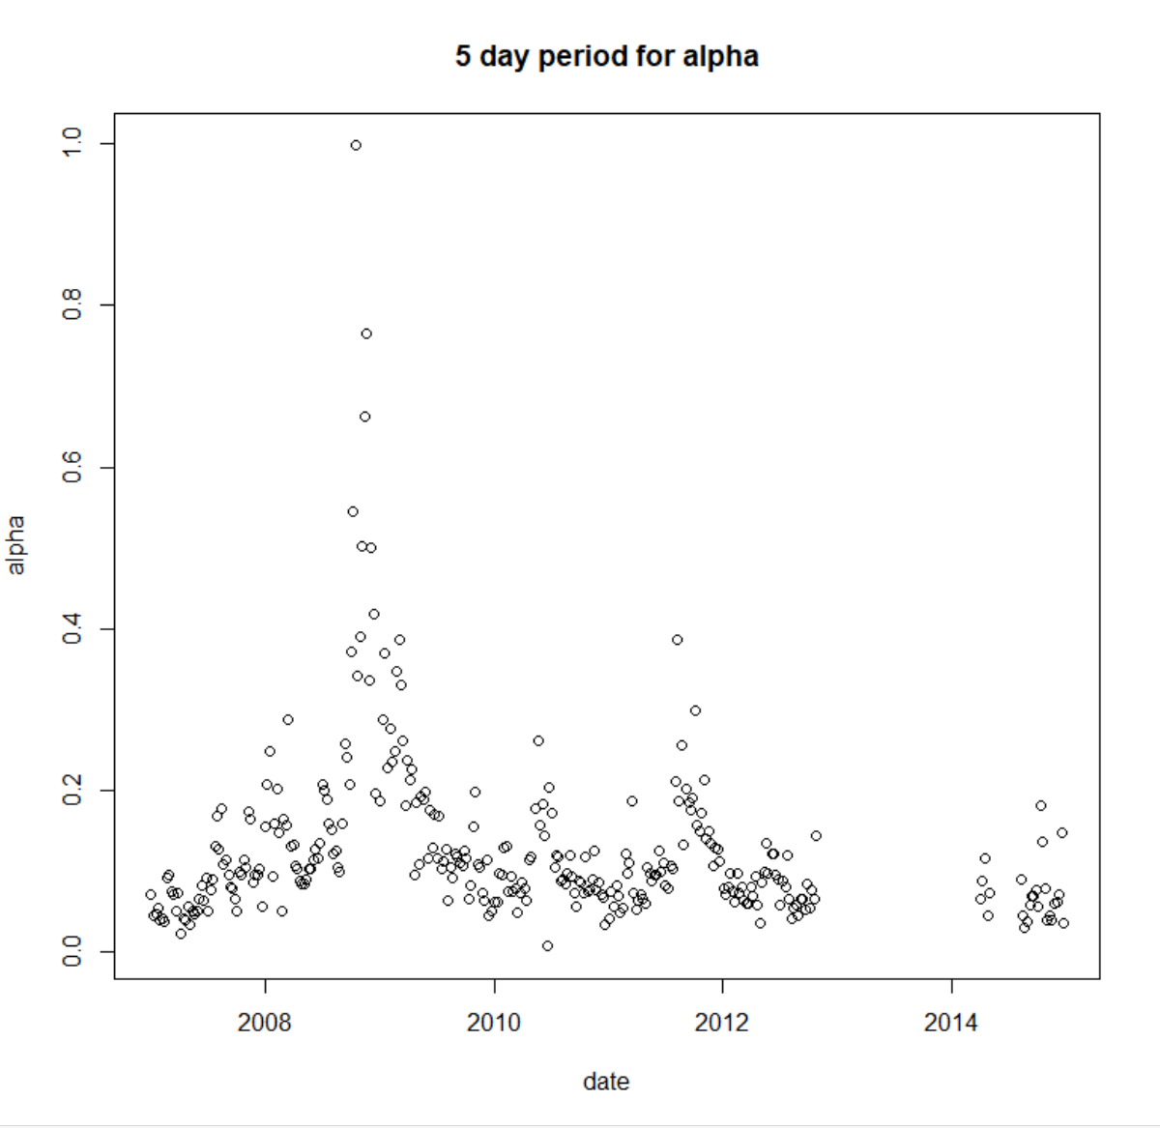

(Five day period without outlier)

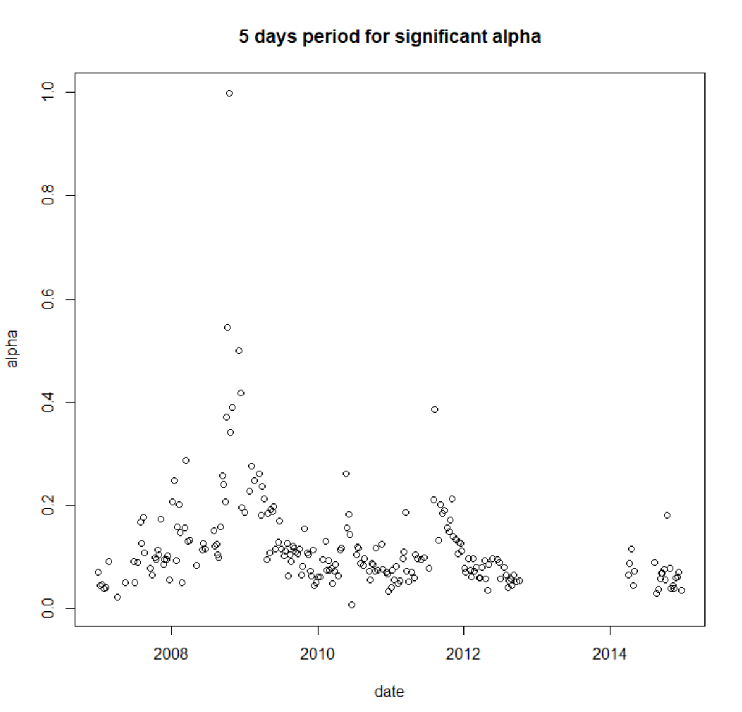

The overall shape of five day period is similar to one day period but the variance is smaller due to larger sample size.

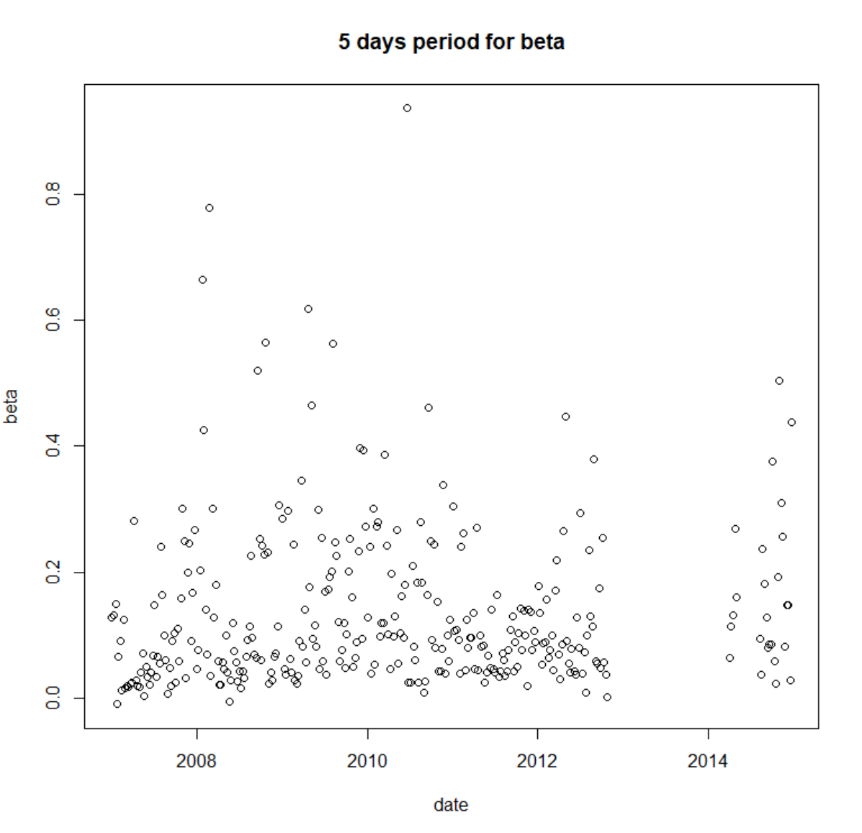

There is no significant outlier in five day period beta.

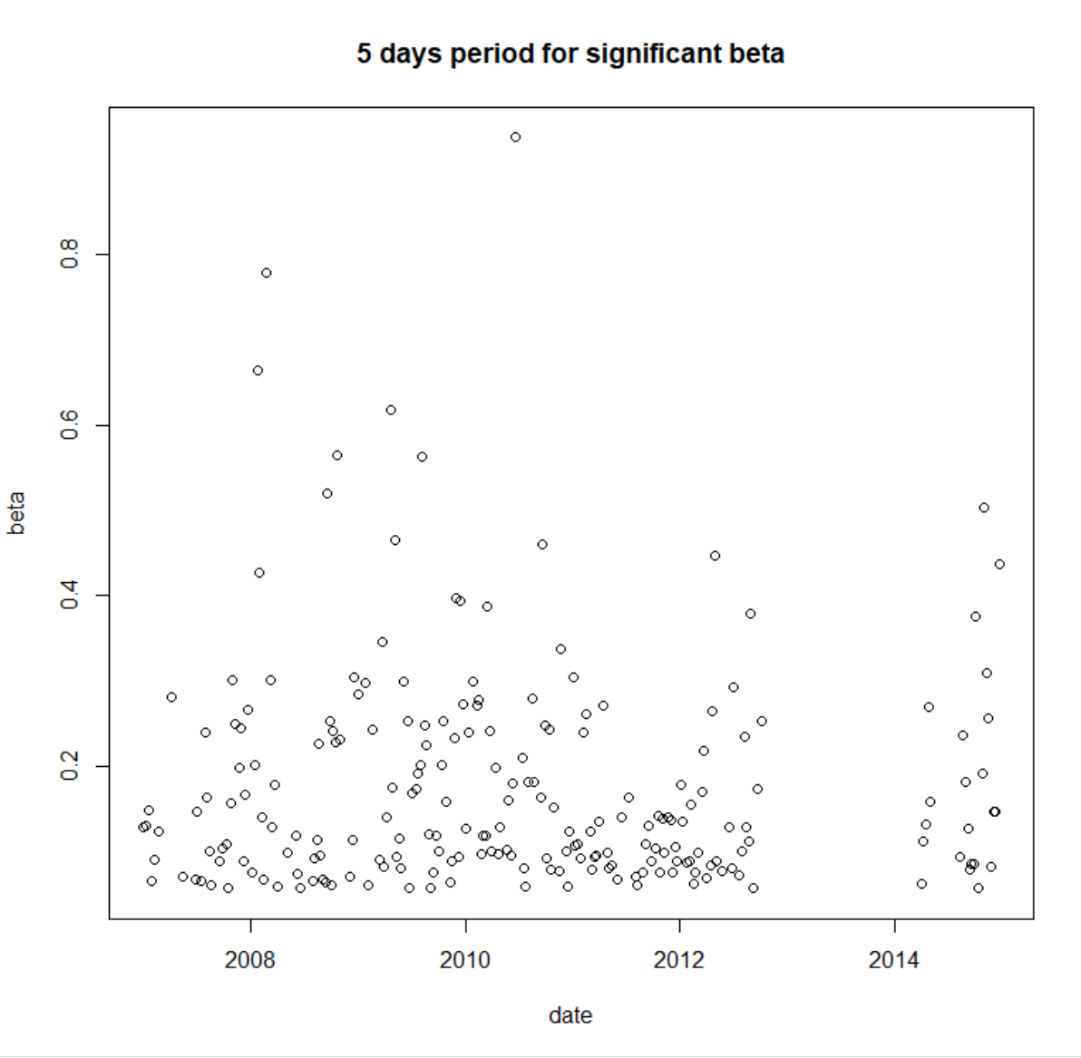

**Theory:**

Log return: the formula of log return is following:



Realized Volatility: the realized volatility is calculated by taking the sum over the past squared return

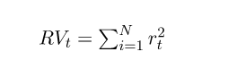

The definition and use of RRV: in order to observed pronounced volatility jumps in high-frequency data instead of in frequent data. to better analyze the jump effects in RV100s, it is helpful to calculate the relative realized volatility to normalize RV100s. RRV has the formula as follows:

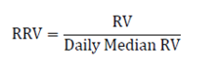

From the mean-reversion feature of Heston model, we have the following:

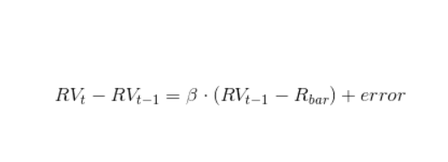

By removing terms, we got the following equation:

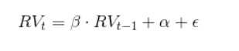

We have the alpha which is daily average and beta as mean-reversion rate. Since the equation is similar to linear equation formula, we decide to test if there is strong linear relationship between mean reversion rate and daily average.